 

|  |
| --- |
| **FPT- aptech computer education** |
| eProject Report |
| Webster Quiz Web |
|  |
| |  |  | | --- | --- | | **Dev Man** | | | **Group Member** | Lê Đức Huỳnh - Student1369660  Lã Việt Anh - Student1370564  Trần Hữu Hoàng - Student1369651 | | **Batch** | T2203E | | **Center** | FPT Aptech Hà Nội | | **Semester** | 3|4 | |
|  |

|  |
| --- |
| - Hà Nội, 09 / 2023 - |

Contents

1. Acknowledgements 3

2. Introduction 3

3. Problem Definition 4

3.1. Problem Abstraction 4

3.2. The Proposed System 4

3.3. Boundaries of the System 5

3.4. Development Environment 6

4. Requirements and Business Flows 7

4.1. Customer Requirements 7

4.2. Activity Diagram 8

4.3. Use Case Diagram 9

5. Design 10

6. Management and Project Planning 11

7. Screenshots 12

8. User Guide 14

# Acknowledgements

* First of all, our group would like to thank Mr Trinh Quang Hoa - who dedicatedly guided and helped us to complete this project.
* However, due to limited time and a few other reasons, despite our best efforts, the project still has many shortcomings and limitations. We look forward to receiving your understanding and further guidance. teachers and friends - we will try to learn from experience and improve ourselves to do better for upcoming projects at the school.
* We sincerely thank you.

# Introduction

Welcome to this document! This introduction will help you understand how this document is organized and the content you will explore while reading.

**Introduction to This Document**

This document is created with the aim of providing detailed information about a specific project or system. It will guide you through each crucial part of the project, starting from defining the problem, moving on to customer requirements, followed by design, and ultimately deployment. You will find diagrams, models, charts, and other essential elements to support your understanding and implementation of the project effectively.

**How the Document Is Organized**

This document is divided into main sections to facilitate easy tracking and information retrieval:

Section 1: Introduction: You are currently reading this section. Here, we introduce the document and its organizational structure.

Section 2: Problem Definition: In this section, we will examine the problem the project or system aims to solve. We will define the issue and review the current system (if applicable).

Section 3: Requirements and Business Flows: We will identify customer requirements and model related business processes in this section.

Section 4: Design: Here, we will present the overall design of the system, architecture, and relevant diagrams.

Section 5: Conclusion: We will summarize the key points in the document and provide guidance on what to do next.

**Document Content**

This document will help you gain a deep understanding of a specific project or system, ranging from problem definition to design and deployment. We provide detailed information, models, diagrams, and other crucial elements to support your work on the project.

Now, let's begin by examining the problem the project is addressing.

# Problem Definition

## Problem Abstraction

The Webster organisation is the leading organization in the world of Oil-Gas Company. They have various branches throughout the world. It has various bonds with different multi-national company. The company wants an application to be build for the jobseeker where the entire candidate as per to the criteria will appear for the online test and based on the result of this the candidate will go for further rounds.

## The Proposed System

The Aptitude test is divided three parts:

* **General Knowledge**
* **Mathematics**
* **Computer Technology**

The test is supposed to be conducted in the linear way, only one link must be active at a time. Each question should carry marks (marks can be decided by the developer from 1 to 5) Steps to be followed:

* **General Knowledge** link must appear which should contain 5 questions. User will click start button for starting the test. It will have a specific time bound for completion, once the time out, it will check the questions attempted. If the user complete the test before the timer out, then they can click on complete/submit button for proceeding further. *Note: when the candidate logs in they can view all three link of test but only General Knowledge one should be active.*
* Once the first part of the test gets completed then it should follows the second link i.e. **Mathematic**s one. The Mathematics section will also follows the same rule as above. *Note: Candidate cannot move back on the previous once it is completed and submitted by them.*
* The last part of the test would be of **Computer Technology section** where again the same rule is to be followed as for the above two but as it is the last step then the candidate will have to click on complete my test button (you can choose the appropriate name also). After clicking on this button the result of the candidate should be calculated and must produce on the screen of the candidate machine. Where if they have cleared it should prompts that “*You have cleared this round, next round would be HR Round”* else no message should be prompted.

## Boundaries of the System

**Project Scope:**

The scope of the system encompasses the following key elements:

* Online Aptitude Testing: The system will facilitate online aptitude testing for jobseekers, comprising three sections: General Knowledge, Mathematics, and Computer Technology.
* Sequential Test Flow: Candidates will progress through the test sections sequentially, with only one section active at a time. The flow will be controlled to ensure that candidates cannot revisit previous sections once completed.
* Question Scoring: Each question in the aptitude test will carry a certain number of marks, which can be set by the developer and may range from 1 to 5.
* Time Constraints: There will be specific time limits for each test section to ensure completion within allocated timeframes.
* Result Calculation: Upon completing all test sections, the system will calculate candidates' results and display them on the candidate's screen.

**Project Boundaries:**

The boundaries of the system are defined as follows:

* Limited to Aptitude Testing: The system's primary function is to conduct aptitude tests for job applicants. It does not extend to other aspects of the recruitment process.
* No HR Interaction: The system does not encompass interactions with HR personnel or other evaluation rounds beyond the aptitude testing phase.
* Candidate Interaction: While candidates can access the system, it does not include functionalities for administrative or HR staff.

## Development Environment

This section describes the environment for system development, including software and hardware requirements.

**Hardware Requirements:**

* Computer: To support system development, at least one computer with sufficient processing power and storage capacity is required. The computer should be capable of efficient data processing and storage.
* Internet Connection: An stable internet connection is necessary for accessing documentation, instructional materials, and other online resources.

**Software Requirements:**

* Operating System: The development environment can operate on various operating systems, including Windows, macOS, and Linux.
* Integrated Development Environment (IDE): It is recommended to use a popular integrated development environment (IDE) such as Visual Studio Code, IntelliJ IDEA, Eclipse, or similar development tools for coding.
* Programming Language: The system can be developed using appropriate programming languages such as Java, Python, C#, or other languages depending on project preferences and developer skills.
* Database: The project may involve the use of a database. This can include database management systems like MySQL, PostgreSQL, or MongoDB, depending on the specific project requirements.
* Testing and Debugging Tools: Suitable testing and debugging tools for the chosen programming language should be integrated to facilitate code testing and error correction.

# Requirements and Business Flows

## Customer Requirements

Client has put forwarded all the list of data’s, he/she required in the application which is stated below:

* MANAGER: Manager will have the authority to enter the details of the candidates appearing for the interview. Details to be maintained like Education details, Personal details, Work Experience. After this Manager will allocate the Username and Password for the candidates.
* Manager can even view the list of all the candidate who is or has appeared along with the result (if achieved)
* If the candidate passes the test, then their names are transferred for next round (HR) round. In the transfer process the data of the candidate must be transferred in the new table (Transfer/ Apti-clear Table) which will be referred by the concern person.
* Manager even will have the responsibility to edit, update, add, save the test question. For doing this the manager has go in the test section available on its profile and can change the question accordingly by clicking the edit button and then saving the new question.
* Report section must be added for viewing the generalized data which can be filter by date, week or month.
* CANDIDATE LOGIN: Each candidate will have their login details provided to them by the Manager. These details must be entered in the candidate’s login section.
* Candidate will start the test then as per the schedule, time allocated for the test. They are supposed to follow the linear mode and once the answer is submitted then it can be changed.
* After finishing the test the candidate will have to click on “Complete my test” and then log out the session

## Activity Diagram

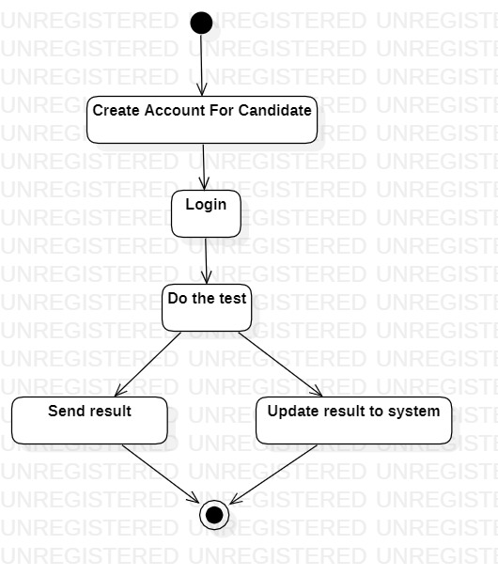

## Use Case Diagram

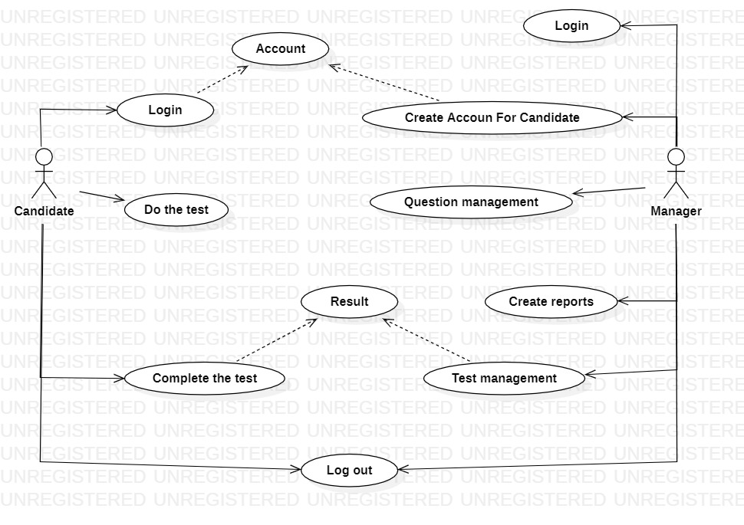

# Design

*This section provides an explanation and presentation of the architecture of the system, using both textual descriptions and diagrams.*

*System Architecture Overview:*

*The system architecture is designed to ensure scalability, reliability, and maintainability. It follows a three-tier architecture model, consisting of the Presentation Layer, Application Layer, and Data Layer. Each layer has a specific set of responsibilities and interacts seamlessly to provide a robust and efficient system.*

*1. Presentation Layer:*

*The Presentation Layer is the user-facing part of the system responsible for handling user interactions. It includes a web-based user interface (UI) developed using ReactJS and Bootstrap. The UI is designed to be intuitive, user-friendly, and responsive across different devices and browsers.*

*2. Application Layer:*

*The Application Layer serves as the core of the system, where the business logic and processing take place. It includes the following components:*

*APIs: RESTful APIs are used to facilitate communication between the Presentation Layer and the Application Layer. These APIs ensure smooth data exchange and support various client applications.We use ASP.NET Core to design API.*

*3. Data Layer:*

*The Data Layer is responsible for storing and managing data used by the system. It includes:*

*Database: We use a database management system SQL Server to store structured data. The database stores user information, test questions, candidate results, and other relevant data.*

# Management and Project Planning

This section will provide an overview of the management approach that our team has chosen. Our team is self-managed, and there is no single leader. We employ a self-managed team model to ensure flexibility and creativity in our work.

* Task Assignment: We typically assign tasks based on each team member's expertise and skills. Each person in the team is responsible for a specific aspect of the project based on their specialization.
* Meeting Frequency: Our team usually holds weekly meetings to discuss project progress and address any emerging issues. Additionally, we may organize ad-hoc meetings when necessary.
* Meeting Content: During our meetings, we review work progress, discuss technical issues, and make decisions regarding project approaches and solutions to challenges. Meetings also serve as a forum for promoting collaboration and exchanging ideas.

The self-management approach allows us to maximize the knowledge and skills of each team member, fostering creativity and quick adaptation to project changes.

# Screenshots

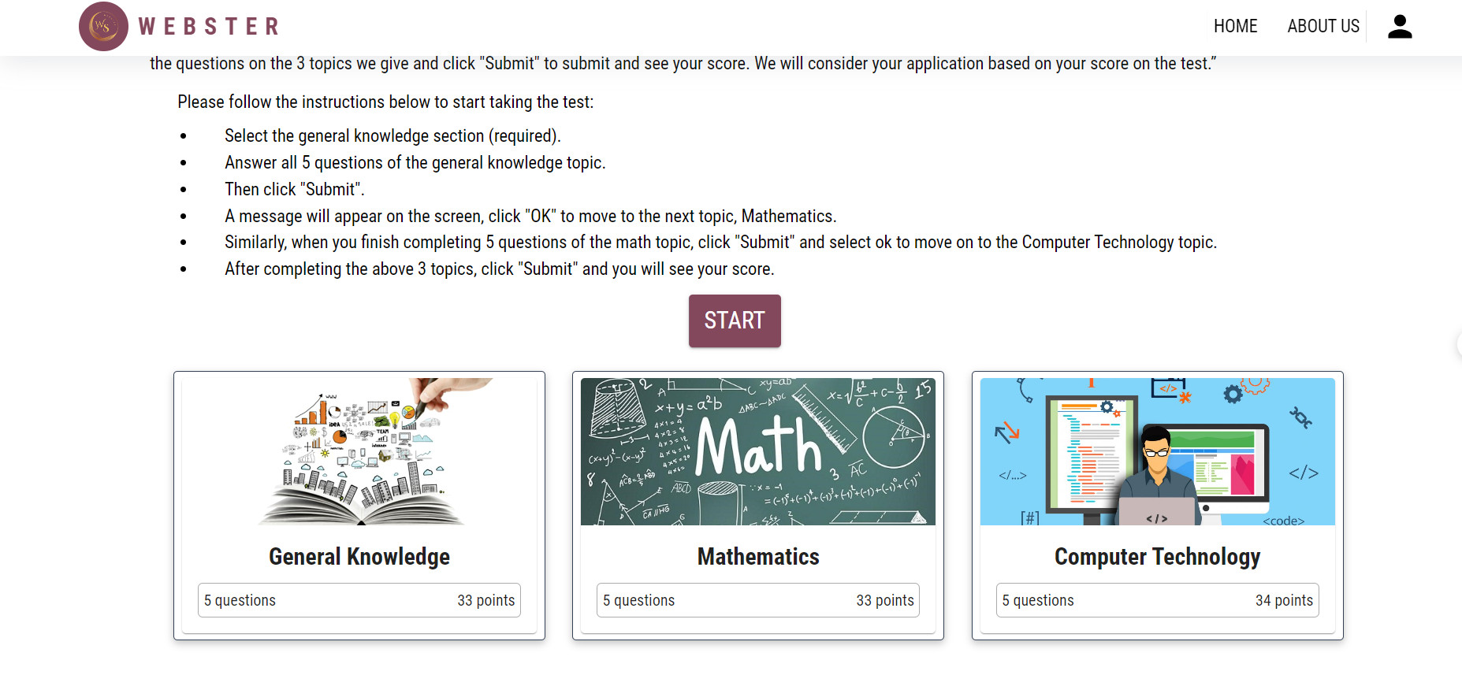

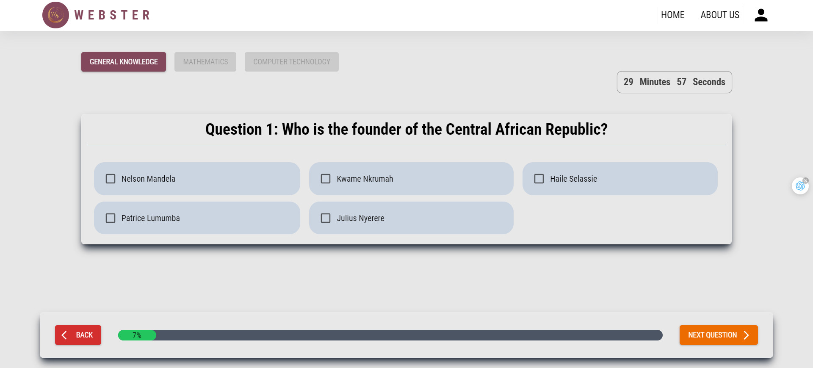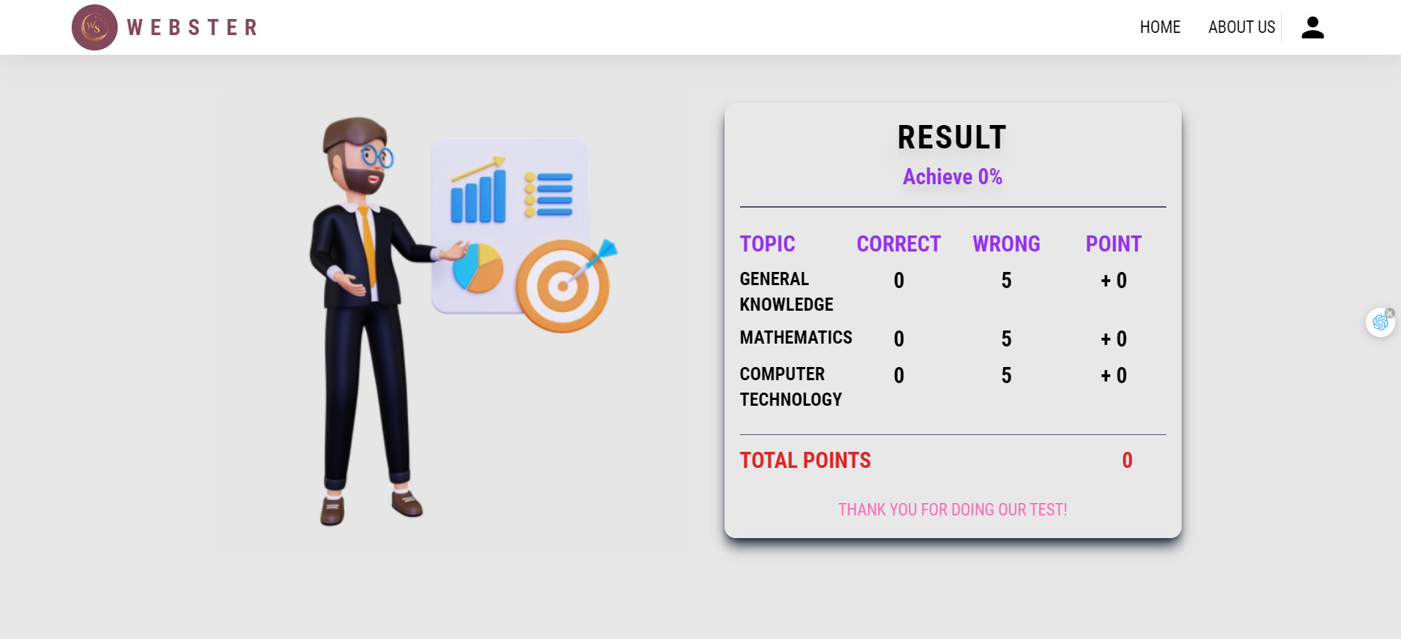

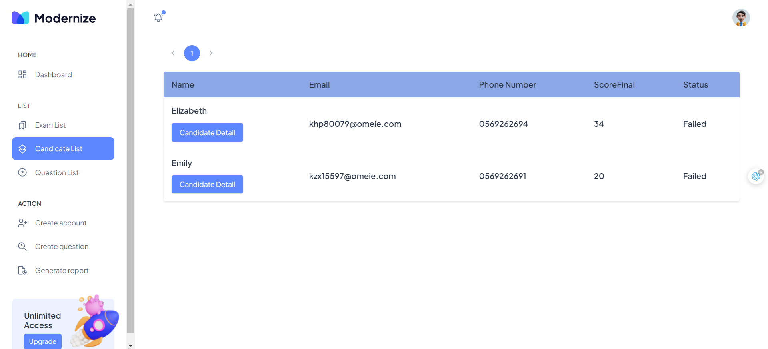

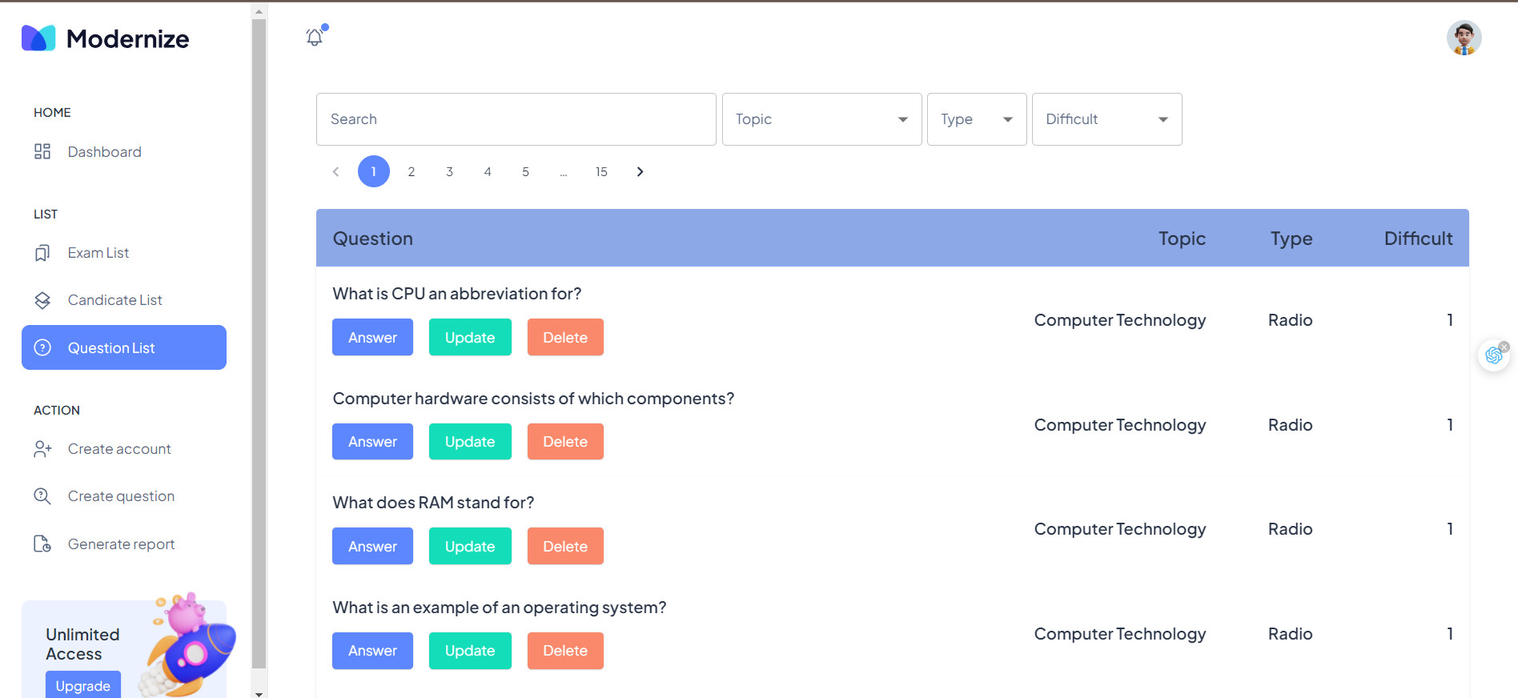

# User Guide

**Login:**

* First, access the login page using the URL provided or the link sent to you via email by our system.
* Enter your username and password.
* Click the "Login" button to access the system.

**Home Page:**

* After a successful login, you will be directed to the system's home page.
* From the home page, you can access various functions and features of the system.

**Taking a Test:**

* Use the navigation bar or menu to participate in a test.
* There will be terms and information about the test for you to review (test type, time limit, etc.). Then, click the "Start" button to begin the test.
* The test consists of three sections, and once you finish one section, you cannot go back to it. Questions may have one or multiple answers, so please consider carefully before clicking "Submit."
* After completing the test, you will receive your results on the website and through an email containing your test result information.

**Reviewing a Test:**

* The system may allow you to review your test through the "Your Test" menu to check your answers.

**Logout:**

* When you have finished using the system, don't forget to log out of your account to protect your personal information.

**--- THE END ---**